**3. Build an image and create container on ansible**

1. Install docker on this ansible machine

Sudo yum install docker -y

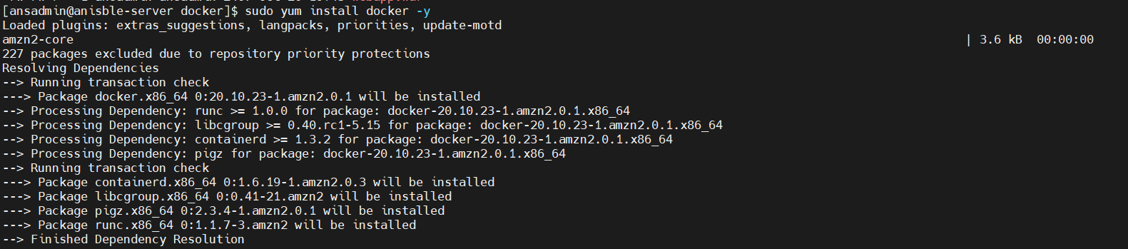

Now autotically docker group got created, check it using cat /etc/group, you can see below line



But ansible user is ansadmin and it will create the docker image, so it needs to add in docker group

sudo usermod -aG docker ansadmin



Check whether it belongs to docker or not.





**Start docker service using command**

Service docker status

Service docker start

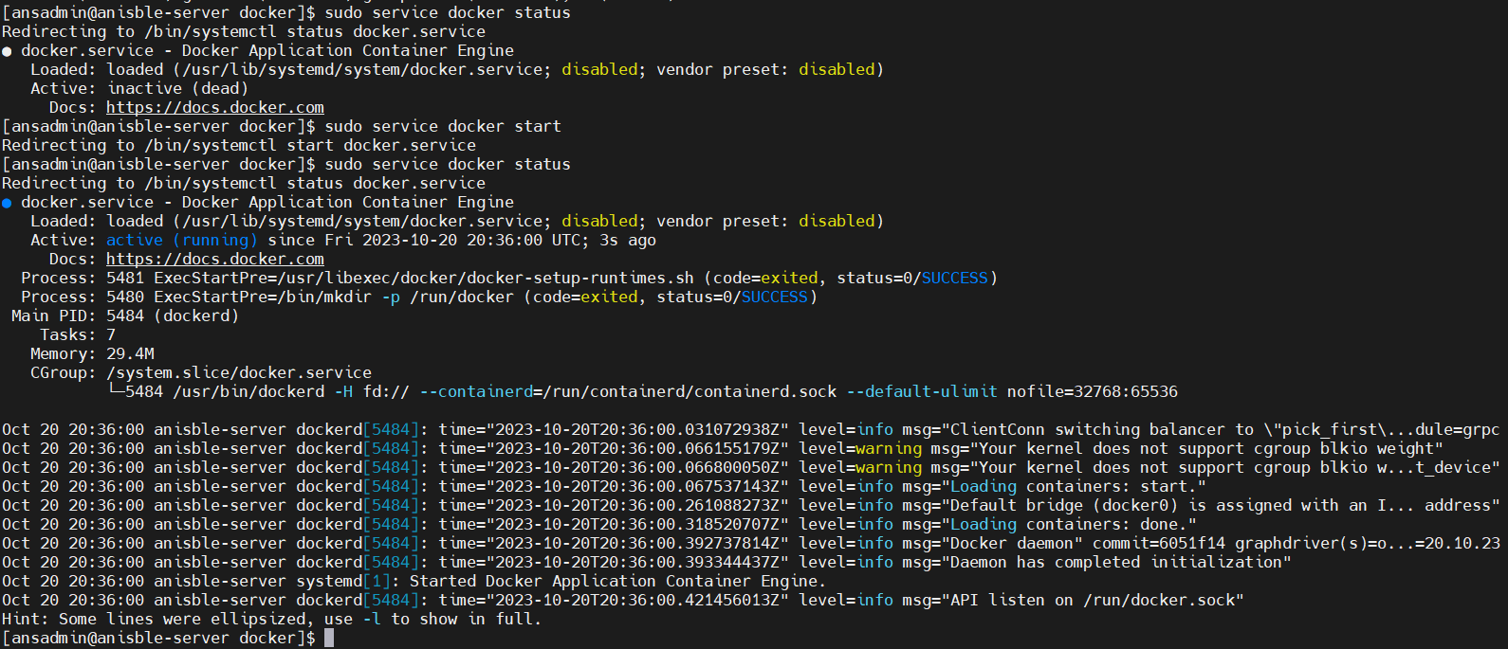

Create the docker file

Vi Dockerfile

FROM tomcat:latest

RUN cp -R /usr/local/tomcat/webapps.dist/* /usr/local/tomcat/webapps

COPY ./*.war /usr/local/tomcat/webapps

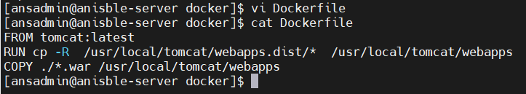

Now build it using docker build command

Docker build -t <image_name:version>

docker build -t registrationapp:v1 .

if you get below error then try to change the permission of file /var/run/docker.sock



sudo chmod 777 /var/run/docker.sock

Now run the build command again.

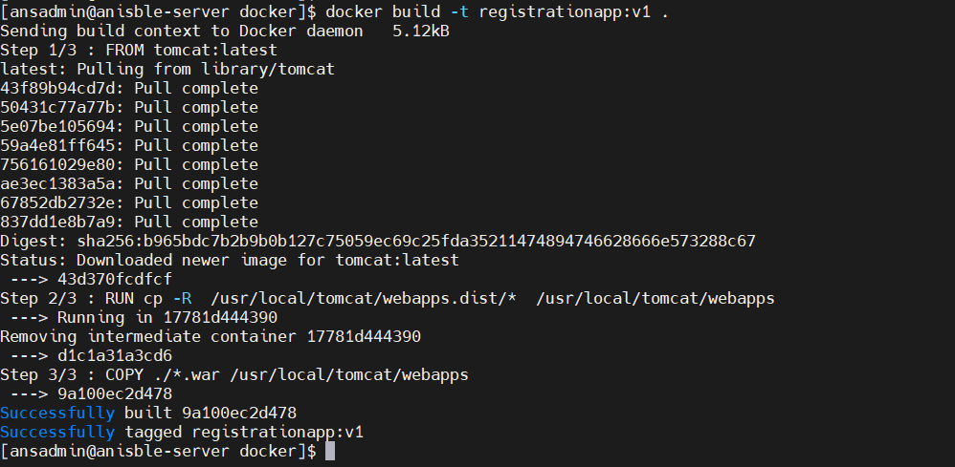

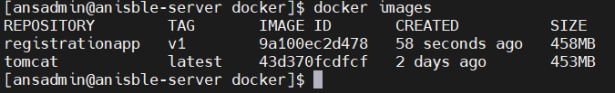

Now create/run the container

Docker run -d –name <container_name> -p <port>:<port> <image_name>:<version>

docker run -d --name registration-server -p 8082:8080 registrationapp:v1



Now this is all manual tasks we will create the ansible-playbook to do same.

Creating ansible-plabook:

cd /opt/docker

create ansible-playbook

vi myapp.yml

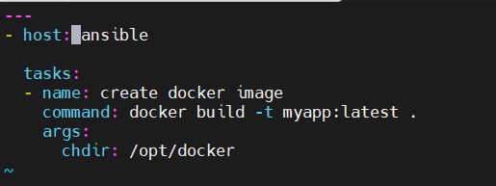

---

- hosts: ansible

tasks:

- name: create docker image

command: docker build -t myapp:latest .

args:

chdir: /opt/docker

- name: run docker container

command: docker run -d --name myreg -p 8085:8080 myapp:latest

Below command will check the syntax

ansible-playbook myapp.yml – - check

ansible-playbook myapp.yml

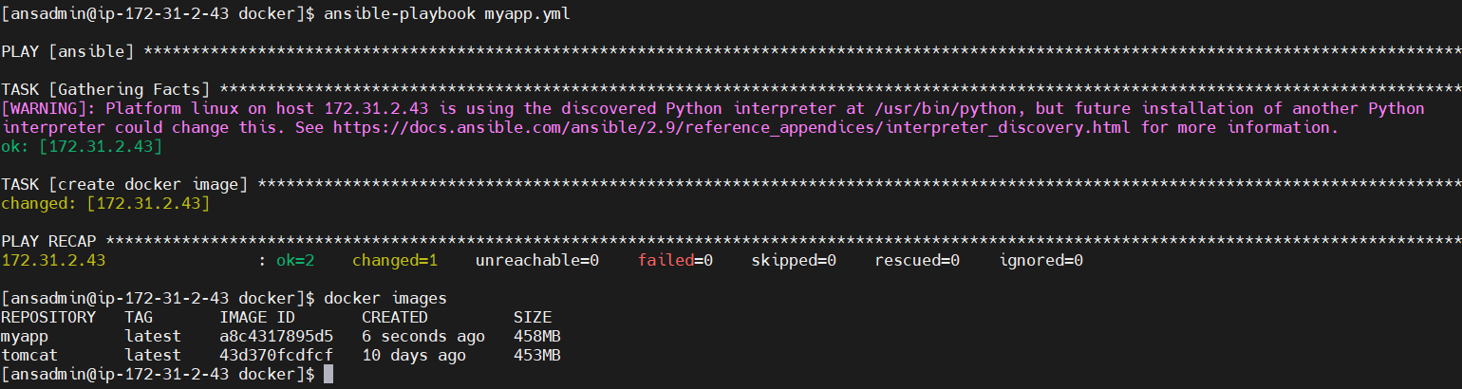

**Now Push the docker image to dockerhub:**

From our ansible system we need to login to dockerhub using below command

Docker login

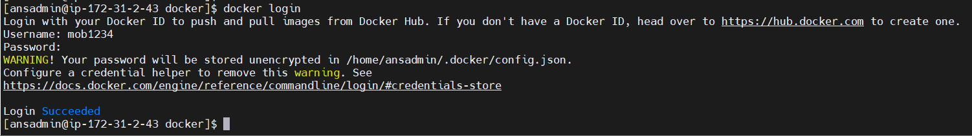

In order to push image we need to create tag of image.

docker images

docker tag myapp:latest mob1234/myapp:v1

docker tag <IMAGE_ID> mob1234/myapp:v1

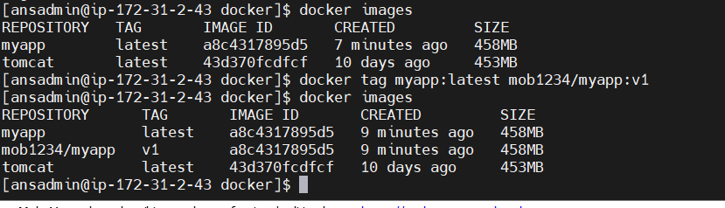

Docker push mob1234/myapp:v1

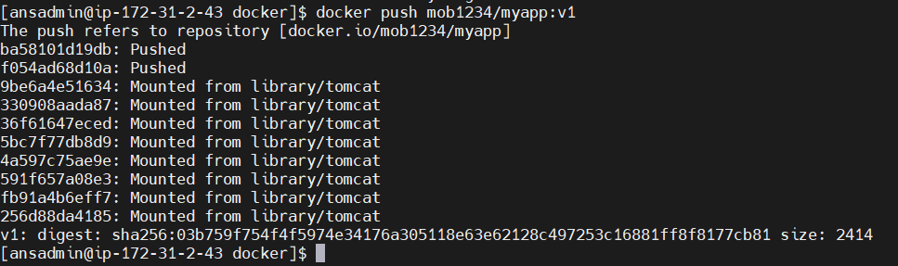

Now same thing we will do with ansible-playbook

Ansible-playbook myapp.yml –check

Ansible-playbook myapp.yml –limit localhost

Ansible-playbook myapp.yml

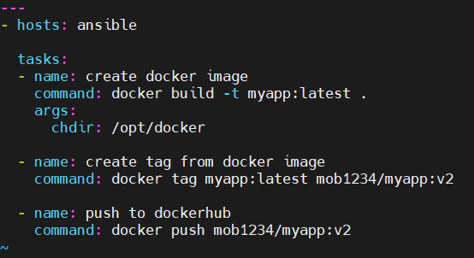

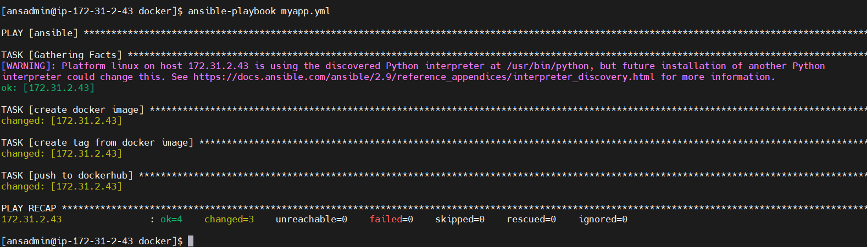

**We will do this using jenkins job:**

Image will get create and pushed but it will not change anything in dockerhub, we want that whenever there is change in github we should create image, for that we need to update our jenkins job.

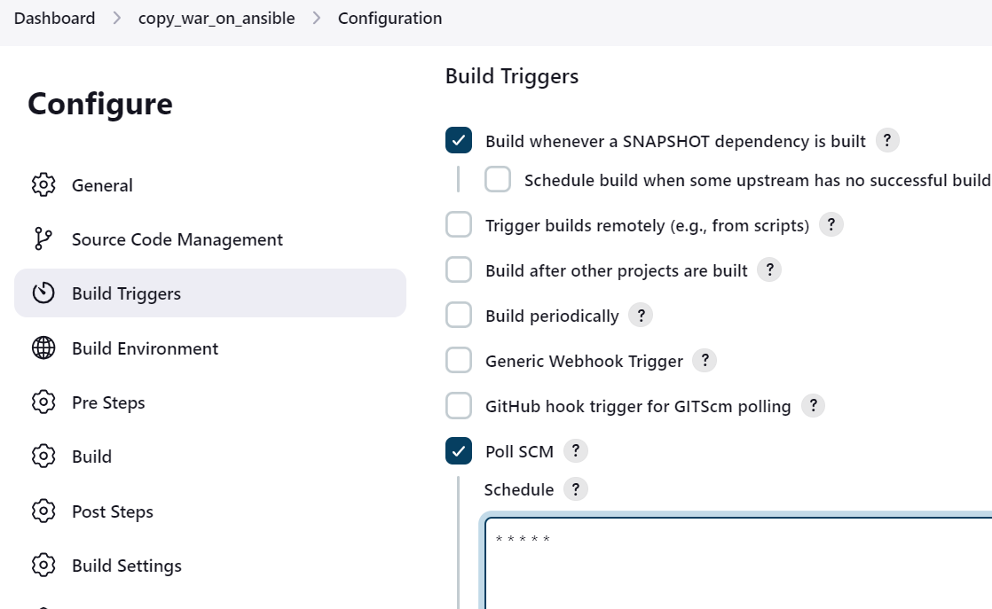

In exec command just put ansible-plabook /opt/docker/myapp.yml

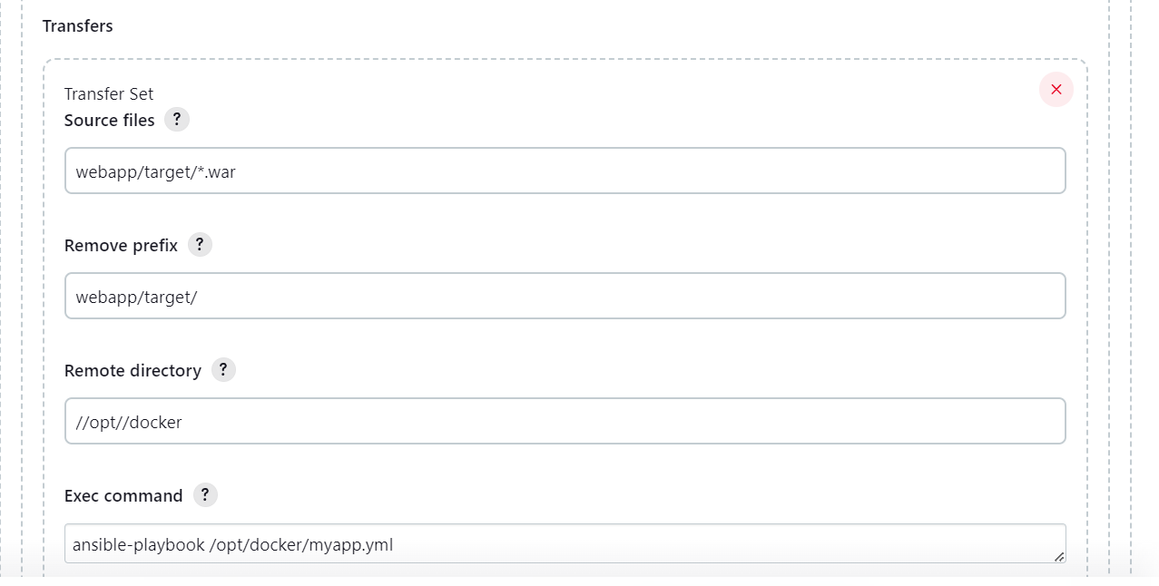

Now update git repo

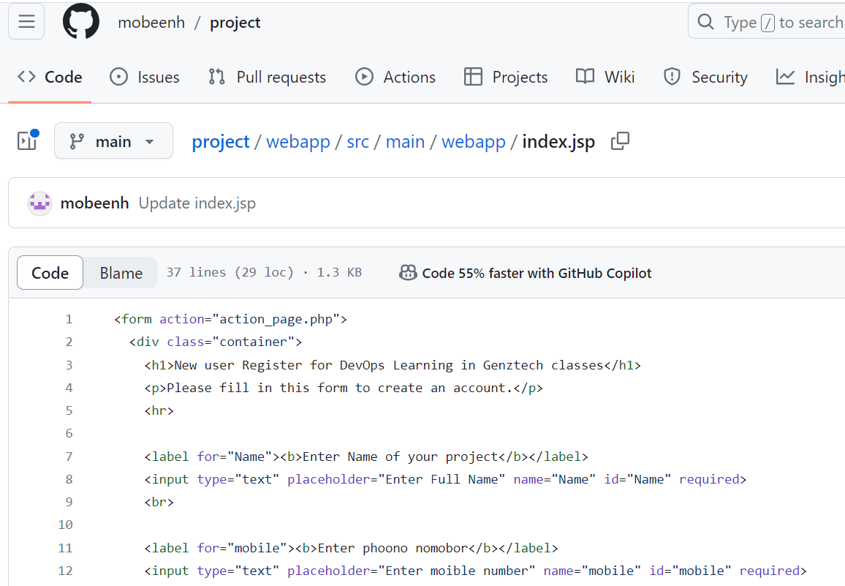

Now you can see it triggered jenkins job

You can verify whether docker image got created or not

**Now we want to run container using ansible playbook:**

For this we will write another playbook in ansible server, but that docker container should get create on dockerhost

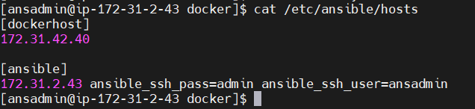

Vi container.yml

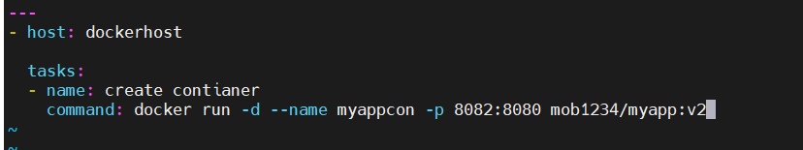

Go on dockerhost:

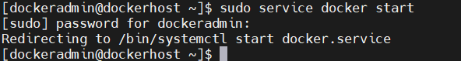

Check what all images and containers are present on that m/c

Docker image prune 🡪 delete all images

Docker rmi image_id 🡪

Docker rm -f cont_id

Now go back on ansible server and run the ansible playbook, if you see below error then change the permission of file in error

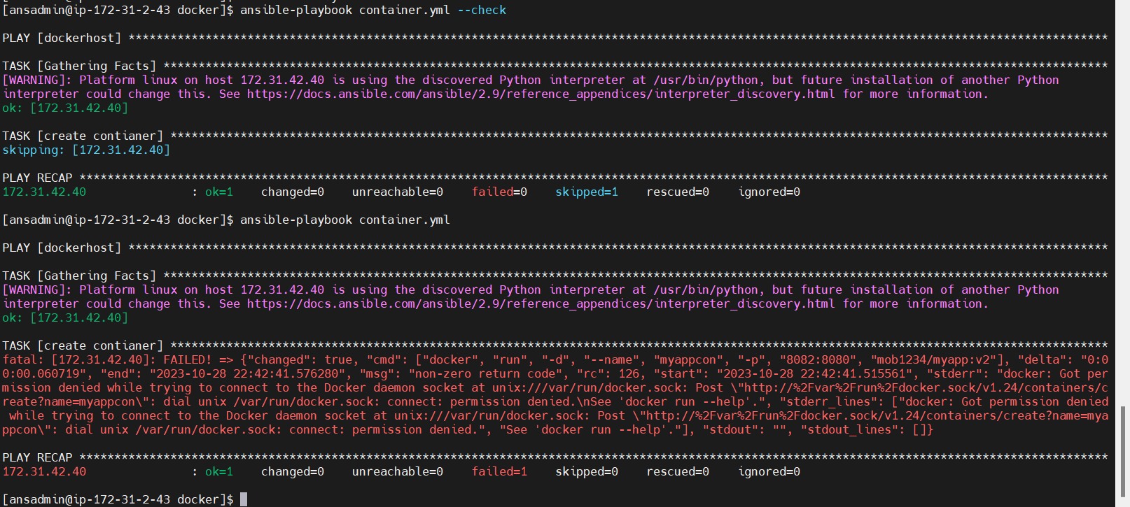

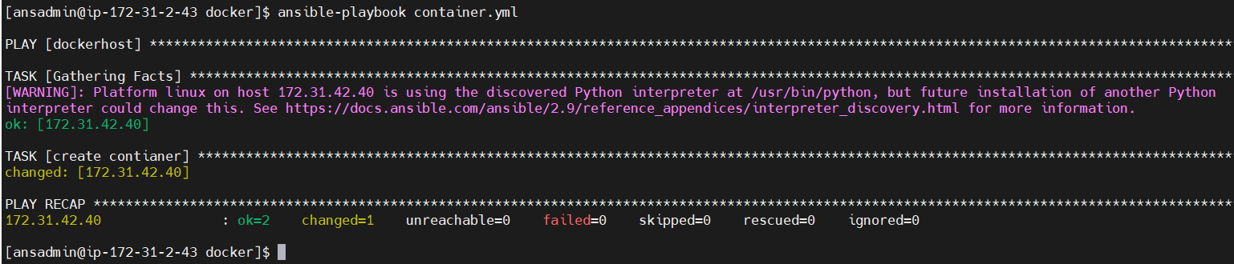

Check the url using ipadrress_ofdocker and port

<http://13.126.222.103:8082/webapp/>